**UNDER EMBARGO UNTIL 00:01 GMT on 25 March 2025**

**Become Your Own Remastering Engineer: Introducing the iFi iDSD Valkyrie**

***Southport, UK:*** iFi audio, a trailblazer in high-fidelity audio components, proudly introduces its latest innovation: the iDSD Valkyrie. This flagship portable DAC/Amp is for those demanding more than pure power or precision; it’s for those who seek the power to shape their own sonic signature.

The Valkyrie fuses unrivalled customization with cutting-edge technology, all in a compact form. It hides thunderous amounts of sonic control with K2HD Technology, DSD Remastering, six additional digital filters and iFi’s signature analog processing. With quad-DAC architecture, 5,700mW* peak output, lossless Bluetooth, and 18-hour battery life, it is unmatched by any other portable on the market.

*\*Peak output measured using iFi’s standards.*

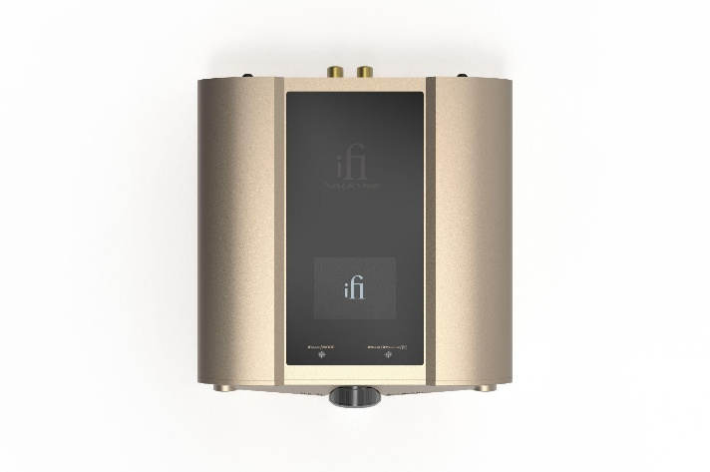

**Studio Secrets, Now Yours**

The iDSD Valkyrie isn’t just powerful, it’s personal. Designed for those who crave musicality and emotional depth, the Valkyrie takes tools once reserved for the world’s top mastering houses and delivers them directly to your fingertips, ready to be experienced at the press of a button.

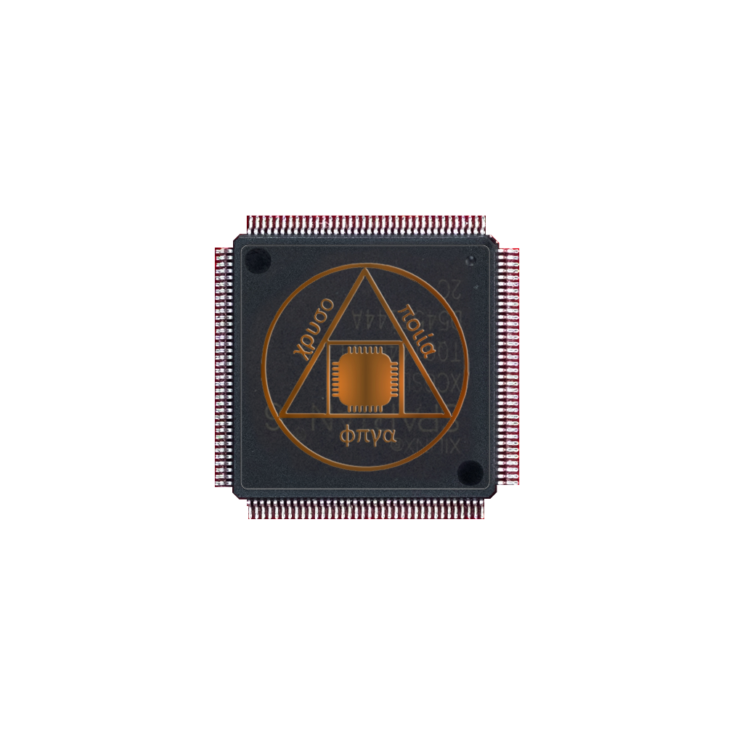**DSD1024 Remastering**

Inspired by the artistry of mastering engineers, the Valkyrie features our bespoke DSD Remastering algorithm, powered by a custom-coded FPGA.

Users can choose between the ‘Normal’ setting, in which DSD signals pass directly to the DAC and PCM signals go through a user-selected digital filter, or ‘Remastering’, with options to remaster to DSD512 or DSD1024.  
   
Similar to the technology used in Sony’s mastering studios, DSD Remastering improves the audio quality of any file by increasing resolution, reducing distortion, and delivering a richer, more detailed sound – akin to a professionally remastered recording.

**K2HD Technology**

At the heart of the Valkyrie is JVCKENWOOD’s renowned K2HD Technology, which restores the warmth and emotion of analogue recordings, ensuring your digital audio never sounds cold or clinical. In particular, it restores music closer to its original master, infusing it with rich, natural harmonics that are normally lost during digitalization*.

The Valkyrie offers this technology in two flavors, ‘K2’ mode and ‘K2HD’ mode, where the former preserves the files’ original resolution.

*\*See the Tech Document for more information.*

**More Ways to Make It Yours**

Alongside these powerful technologies, the Valkyrie also offers six digital filters, including Apodizing, GTO, Bit Perfect, Standard, Minimum and Transient Aligned, giving you more ways to experience your favorite music and discover the best for your ears*.

Complementing its digital customization suite, the Valkyrie features advanced analogue processing features that are unique to iFi such as XBassII, XPresence and XSpace.

Unlike other products, Valkyrie uses switchable analogue circuitry for its EQ modes, rather than Digital Signal Processing (DSP). This preserves audio quality and allows for more natural frequency adjustment, with less phase shift and distortion.

XBassII adds back lost bass frequencies, while XPresence adds a touch of mid-presence to the sound to deliver more upfront midrange. XSpace, also found across iFi products, enhances the audio by creating a spacious sound field, adding depth to the more two-dimensional two-channel experience.

* **XSpace:** Expands the soundstage, creating a wider, more spacious listening environment created with closed-back headphones in mind.
* **XBassII:** Restores lost bass frequencies open-back headphones and delivers deeper, fuller low-end in closed-backs.
* **XPresence:** Brings midrange and vocals forward, enhancing vocal clarity and presence for a more engaging, intimate sound.

*\*See the Tech Document for more information.*

**Quad-DAC Architecture and aptX Lossless Bluetooth**

The Valkyrie is built around four Burr-Brown DACs in a hybrid multi-bit configuration, drawing from iFi’s long-standing experience with the legendary multi-bit Philips TDA1541A. This design captures the magic and impact of the iconic multi-bit chipset, but with superior low-level linearity for breathtaking detail*.

As pioneers of Lossless Bluetooth, iFi has equipped Valkyrie with the latest flagship Qualcomm chipset to deliver CD-quality audio via aptX Lossless, and Hi-Res playback via LDAC.

*\*See the Tech Document for more information.*

**Exceptional Power for Audiophiles**

Audiophiles no longer need to dream of their home system’s power and features on the road - the Valkyrie brings the power, comfort, and quality of a home setup with you wherever you go.

The Valkyrie delivers approximately 44% more power than iFi's flagship, multi-award-winning iDSD Diablo 2 when driving current-hungry 16Ω headphones, and up to a staggering 5,700mW peak output power – or 2,258mW RMS. The Valkyrie can therefore drive the hungriest of headphones all in a portable body, so you can take your premium audio set up with you, wherever you go.

*\*Peak output measured using iFi’s standards.*

**xMEMS Support**

The iDSD Valkyrie supports IEMs using xMEMS, an innovative speaker technology pushing the boundaries of headphone performance.



xMEMS speaker technology implements both actuation and diaphragm in silicon producing the world’s fastest and most precise speakers for IEMs. With these next-generation speakers, there’s virtually no phase shift and they are close to 150 times faster than regular mechanical drivers.

*\*See the Tech Document for more information.*

**Colossal Capacity, Silent Stability**

To power all its advanced features, the Valkyrie requires a serious battery configuration. Under the chassis are four 5,000mAh lithium-ion batteries, totaling a colossal 20,000mAh.

Not only do batteries provide sound free from electrical interference and noise, but they do so with enough life to last up to 18 hours of playback on a single charge – a flight from London to New York… and back.

Fast charging via USB-C means the Valkyrie takes from just 2.5 hours to recharge.

**Key features and functionality:**

* **K2HD Technology:** Restores the richness of analogue sound, offering a natural listening experience.
* **DSD 1024 Remastering:** High-performance FPGA professionally remasters audio to DSD512 or DSD1024 for exceptional clarity and detail.
* **Quad DAC Architecture:** Four interleaved Burr-Brown DACs deliver the dynamics of famed multi-bit chipsets, with superior low-level linearity.
* **5,700mW Peak Output:** Delivers formidable power for driving the most demanding headphones.
* **Lossless Bluetooth and xMEMS Support:** Delivers CD-quality Bluetooth via aptX Lossless and next-gen driver compatibility for ultra-fast, precise sound.
* **20,000mAh Battery:** 18 hours of continuous playtime, with fast charging via USB-C in just 2.5 hours.

**Pricing & Availability**The iDSD Valkyrie is available to purchase from ifi-audio.com, or through our Elite Dealer Programme for $1,699 USD. This program offers select dealers the exclusive opportunity to offer our premium products, including the NEO iDSD2, Diablo 2, NEO Stream, and iCAN Phantom.

**About iFi**

iFi is the sister-brand of Abbingdon Music Research (AMR) and is headquartered in Southport, UK. The two brands respectively design and manufacture portable, desktop and lifestyle audio products and high-end hi-fi components. Combined in-house hardware and software development teams and a ‘music first’ approach enable iFi and AMR to create advanced audio products that deliver new levels of design, functionality and performance at their respective price points. Since iFi’s formation in 2012, its products have earned many awards around the world, helping it to become one of the fastest-growing brands in its field.

[www.ifi-audio.com](http://www.ifi-audio.com)

**General Specifications**

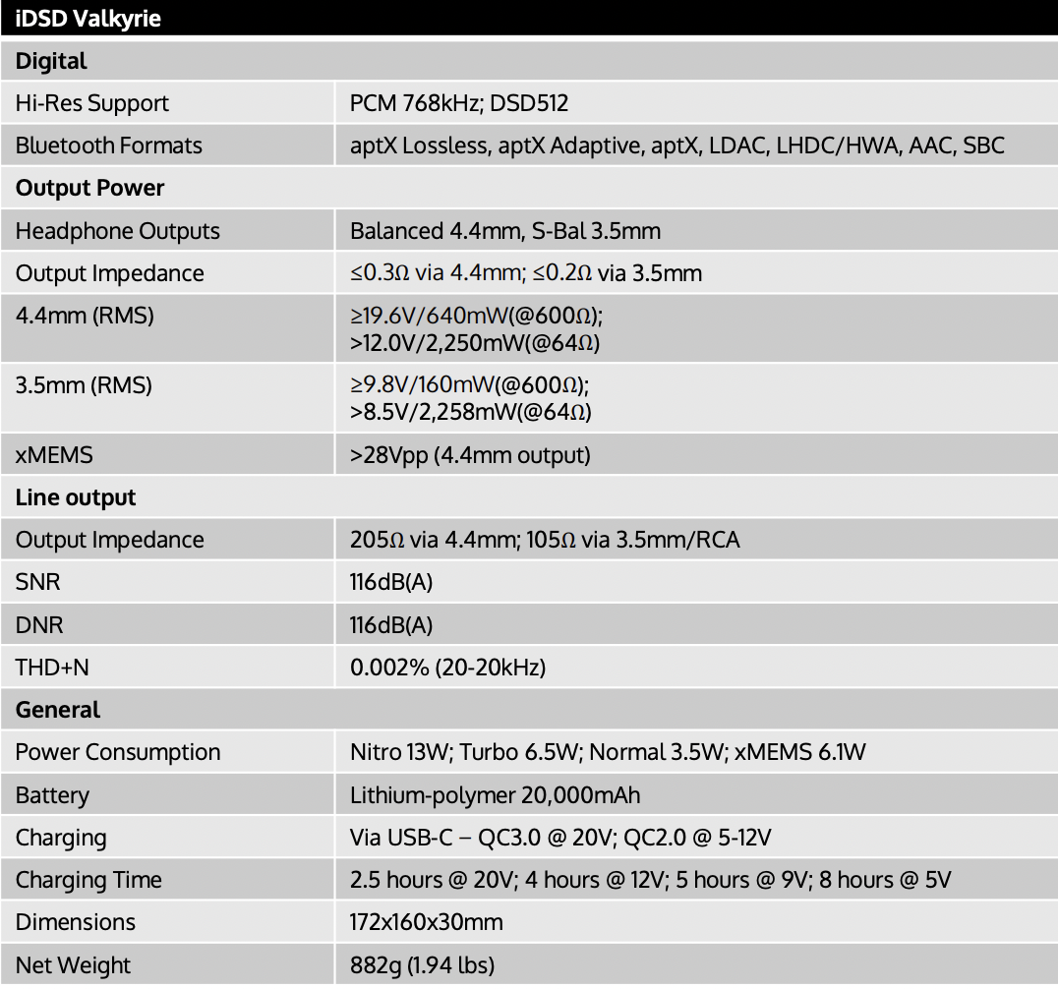

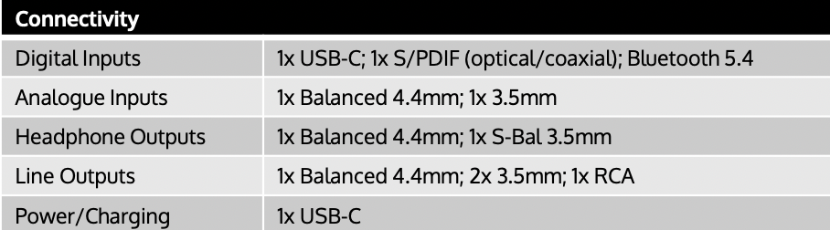

*"K2 Technology" and "K2HD" are trademarks or registered trademarks of JVCKENWOOD Corporation. For more information, please visit https://www.jvckenwood.com/en/technology/k2.html*